Jacobs University Marketplace
A project by:
- Mario Myrtaj
- Marcos Sosa
- Mourad Ouazghire
- Giorgi Maisashvili
The web application we are building is a marketplace where students from Jacobs can advertise their 2nd hand objects they want to trade away. Users can create their account using their Jacobs email at the app, where they can interact as a buyer, seller, or both. Every user has a unique username. Acting as a seller they can list items for sale, write a title and an item description, add pictures for the items, describe the condition, and list the item in a specific category. Lastly, sellers can browse buyers' requests for different items and contact them. Acting as a buyer you browse for items on sale or go filtering them by categories of their interest, they can sort them with different options (alphabetic, oldest to newest, price lowest to highest, and so on), and they can see the product details, can make a request for specific items with a title, description, and an optional image. Buyers can save their favorite sellers for ease of contact in the future. Users can communicate with each other via messages in-app where they can further discuss details and so on. A buyer can write to the sellers for their interested item and the seller can write to buyers when they can provide the requested item from the buyer. Users can get rated/rate for their satisfaction, friendliness, reliability, and response time. When a certain time passes (30 days), after a user has posted an item to sell or when they have requested a specific item, their post gets deleted automatically by the app. Users can contact admins to get help with issues or questions. Sellers can also get their posts “boosted” by contacting admins.
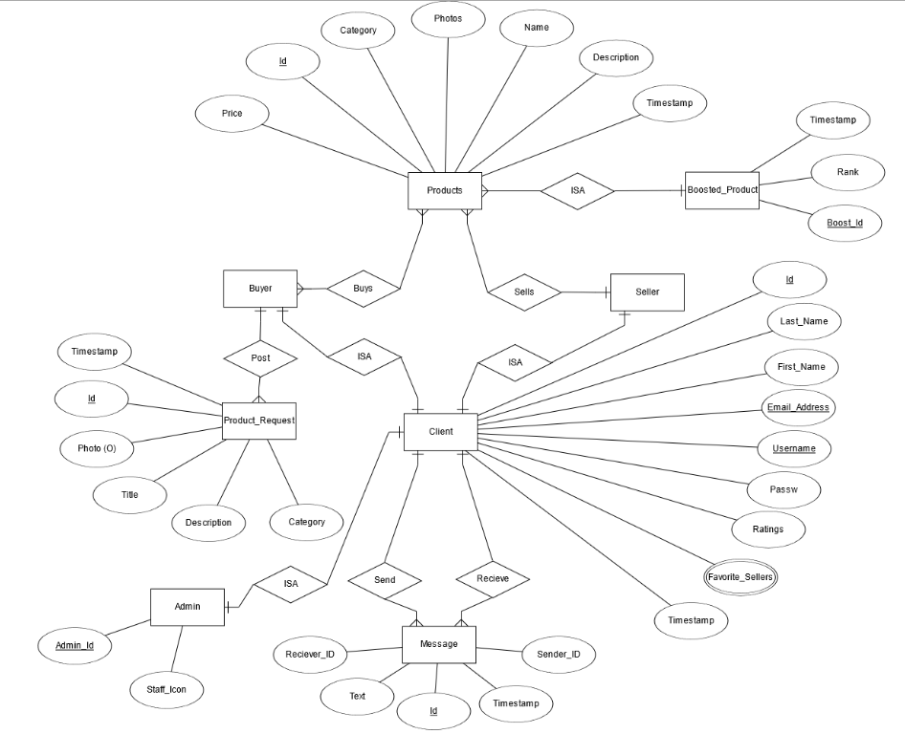
Interface:
- Registration and login page.
- 3x3 first page list of the items being sold in the marketplace.
- Dropdown list sorting the different items by category.
- An interface for the seller to write about the details of their item. e
- Implementing a chat box for live interactions between the buyer/seller.
- Displaying a product page interface for the buyer which will include all the details about the product specified by the seller, which has a “Add to favorites” option.
- A page post-order for the buyer for rating satisfaction, friendliness, reliability, and response time of the seller.
- A user-specific page that displays a list of the user’s favorite sellers.
Interactions:
- Be able to create an account with one’s Jacobs email, and login with it right after
- Scroll down through the marketplace page to find out the items that are for sale.
- Sellers are able to write the title, condition, price, pictures, and the category to which their item belongs, then publish it with a “publish” button.
- Ability for the buyer and seller to communicate live on our platform.
- Adding sellers to favorites for ease of contact in the future.
- Giving a personal subjective rating for the seller after one has concluded his transaction.
- Boosting posts to get more attention from other users

